**Useful Telephone Numbers**

Surgery 0113 2602262

Fax 0113 2328090

Neighbourhood Team 0113 8432635 (District Nurse)

Midwife 0113 2066241

Health Visitor 0113 2954877

Social Services (Cross Gates) 0113 2603111

Seacroft Hospital 0113 2648164

St James’s Hospital 0113 2433144

Leeds General Infirmary 0113 2432799

Wilsons Pharmacy (next door) 0113 2648038

St George’s Minor Injury Unit 0113 3929801

Shakespeare Walk in Centre 0113 2951132

PALS LTH 0113 2066261

PALS The Mount or Becklin Centre 0800 05252790



**Telephone:** 0113 2602262

**Online:** www.austhorpeviewsurgery.nhs.uk

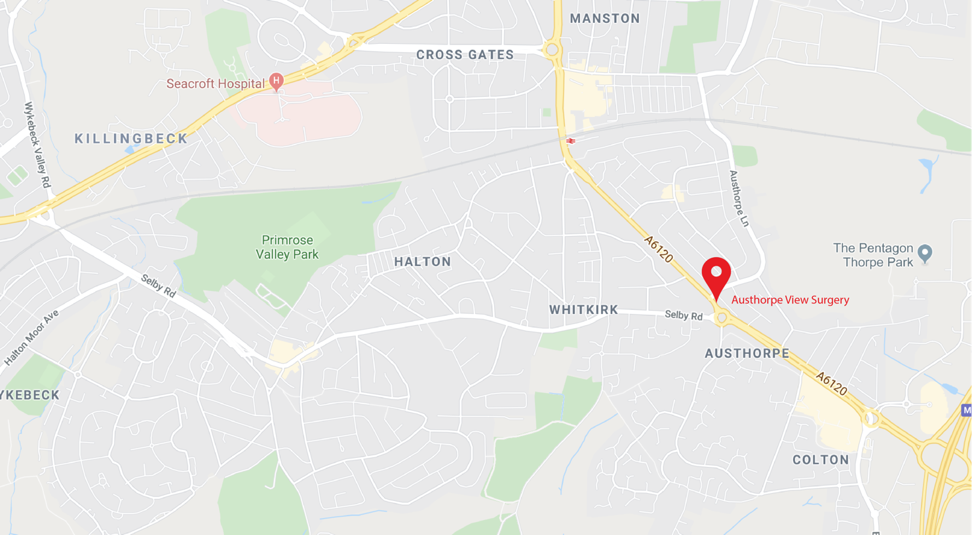

**Dr Christine A Clyde**

**Dr Ana Nagarajan**

**The Family Doctors**

**5 Austhorpe View**

**Whitkirk, Leeds, LS15 8NN**



**Tel: 0113 2602262 Fax: 0113 2328090**

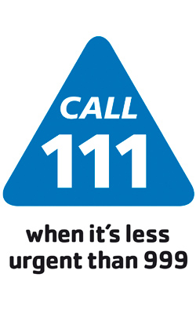

www.austhorpeviewsurgery.nhs.uk

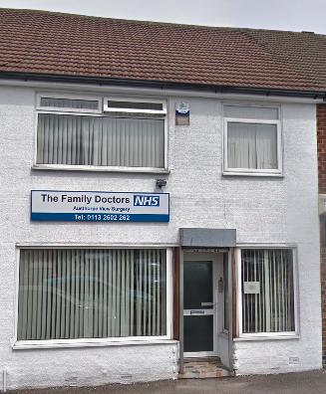

**Opening Hours**

**Monday 08:00 – 18:30**

**Tuesday 08:00 – 18:30**

**Wednesday 08:00 – 18:30**

**Thursday 08:00 – 18:30**

**Friday 08:00 – 18:30**

**Saturday Closed**

**Sunday Closed**

**New**

**Patients**

**Welcome**

**Car**

**Parking**

**Available**

**About the Practice**

The Family Doctors Practice is a general medical service under the new General Medical Services contract from 1st April 2004.

Our aim is to provide the best possible medical care for our patients, but in return we ask that patients respect our staff and the services we provide. You can help us by keeping the appointments you make and by requesting any repeat prescriptions in the correct way. We will not tolerate any abusive or threatening behaviour towards any of our staff.

Information about patients will only be passed to other medical professionals with the patient’s permission. Where practicable a written consent will be obtained. We are registered and operate within the Data Protection Act.

Although we do not have disabled access to the surgery, we will endeavour to accommodate all our patients’ needs. If we feel this cannot be met, then an alternative surgery will be recommended.

**Privacy & Confidentiality**

All patient information is recorded on computer, and we are registered under the data protection act. The practice will ensure that confidentiality is maintained at all times by all members of the practice team. We are guided by the NHS Confidentiality Code of Practice.

**Online Services**

You can register for online access to the practice which enables you to make appointment and request prescriptions online. Please ask at the reception to register.

**When we are closed**

For immediate life-threatening medical emergencies call 999 When you need medical advice quickly, but it is not an emergency call 111

When this surgery is closed, Local Care Direct has a team of GPs and nurses who can respond to your needs. For the out of hours service when the surgery is closed, ring the surgery and your call will be re-routed through to Local Care Direct, or you will be given an alternative number to call.

Please use this service rather than the A&E department for problems you would normally consult the practice about.

Please do not ask to see a doctor out of hours unless you genuinely cannot wait until the surgery re-opens.

Alternatively, there is a Minor Injuries Unit at the St Georges Centre, St George’s Centre, Middleton 0330 311 5106

There is a walk-in centre at Shakespeare Medical Centre which is open 365 days a year from 8:00 – 20:00 Tel: 0113 295 1132

Friends and Family

There is a suggestion box in the reception area for patients to give feedback and also a questionnaire is given periodically to patients regarding improving services.

We also use Friends and Family for feedback on our services.

Your Responsibility to us:

Let us know if you change your name, address or telephone number. Ensure that you keep your appointments or contact us as soon as possible if you cannot. Only request a home visit if the patient is too ill to attend the surgery. Keep telephone calls brief and avoid peak times with non-urgent matters. Test results take time so please do not ring before you have been asked to. Enquiries that have been ordered by the hospital must be obtained through them and not the surgery.

We ask that you treat the Doctors and staff with courtesy and respect. Please take the time to read our practice booklet.



Our Responsibility to You

The Family Doctors aim to provide the highest quality healthcare to all our patients. We ensure holistic integrated care with focus on the continuity of care. We put patients at the heart of everything that we do.

We undertake to treat you with respect and courtesy at all times. Help you to make decisions about your health.

We will guide you through the health care system. Maintain confidentiality in what we discuss and in the records that we keep about you.

Keep up to date with developments in health care by encouraging lifelong learning and professional development.

Nurture a supportive and harmonious working environment for staff and patients.

Encourage behaviour which promotes health and prevents disease.

Waiting Time

We run an appointment-based system. Our aim is that you should wait no longer than 30 minutes after the time given without an explanation.



Chronic Disease Management

We offer our patients with chronic diseases annual health checks with some being reviewed 6 monthly. You will automatically be invited at appropriate times.

The chronic disease register includes patients with:

Chronic Kidney Disease, Diabetes, Epilepsy, COPD, Hypertension, Hypothyroidism, Asthma, Stroke, Mental health, Heart failure.

Learning Disabilities

We offer all our patients with moderate or severe learning disabilities an annual health check to ensure all their health needs are being met to the highest standard possible.

Health Promotion

We offer services to keep you healthy and reduce the risk of developing health problems. These include dietary advice, weight management, exercise advice, smoking and alcohol support.

Stopping Smoking

This is one of the single biggest changes you can make to improve your well-being and maintain your health. If you would like help with stopping smoking you can call free One You Leeds Stop Smoking service directly to receive support, motivation and medication to help in your attempt to quit. One You Leeds: 0800 169 4219

Cervical Screening

We offer cervical screening for those eligible women invited by the national screening programme. Once you have received an invite simply book an appointment with our practice nurse.

Midwife Clinic

We have an antenatal clinic every Wednesday morning at the surgery.

**Comments or Complaints**

We make every effort to give the best service possible to everyone who attends out practice. Please feel free to make suggestions or comments to help improve our service. You can make suggestions verbally to any of our staff or put them in writing to the Management Team.

We understand that things can go wrong resulting in a patient feeling they have cause for complaint. If this is the case we are happy to investigate the matter and resolve as quickly as possible. We seek to learn lessons when things go wrong and look at how we can prevent a similar situation in the future. Please request a complaint form from reception or the form can be downloaded from our website. Our Practice Operations Manager will then look into your concerns.

**Other Practice Policies**

**Confidentiality & Medical Records**

The practice complies with GDPR and access to medical records legislation. Reception and administration staff require access to your medical records in order to support your care and treatment. Staff are bound by the same rules of confidentiality as clinical staff.

**Freedom of Information**

Information about the doctors and staff required for disclosure under this act can be made available to the public. All requests for such information should be made available to the practice manager.

**Access to records**

In accordance with GDPR and access to Health Records Act, patients may request to see their medical records. Such requests should be made using our subject access request for or in writing to the Practice Operations Manager. No information will be released without a patient’s consent unless we are legally obliged to do so (for example if there are child protection concerns).

**NHS England**

NHS England (the NHS Commissioning Board) is empowered to make arrangements for the provision off Primary Medical Services.

**How to contact NHS England**

Telephone: 0300 311 22 33

Email: [england.contactus@nhs.net](mailto:england.contactus@nhs.net)

Post: NHS England, PO Box 16738, Redditch, B97 9P

**Our Doctors**

**Dr Christine Clyde MB ChB, PhD, DCH, DRCOG, PG(DIP)ENT**

Dr Clyde qualified from Leeds in 1987 her specialist interest is ENT.

**Dr Ananthalakshmi Nagarajan (Dr Ana) MBBS MRCGP**

Diploma in Dermatology (skin), Cardiff University

Qualified in 2000, India

Private examinations and reports

We endeavour to undertake our private work in a timely and efficient manner and we do understand the importance of many of the reports we do. Please ask at reception for prices.

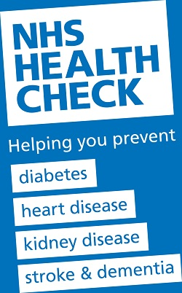**NHS Health Check**

In line with a national programme, we offer a free health check for all adults aged 40 – 75. This involves a lifestyle assessment with simple blood tests which in part helps us to calculate a vascular risk score. We can subsequently offer advice and if appropriate treatment to help reduce the risk of you becoming unwell in the future. Please ask at reception to book an NHS health check. All eligible will be invited in time, but you are welcome to request one sooner if you meet the criteria. Note if you already have a chronic disease and have annual reviews at the surgery this is unnecessary as we already calculate this for you.

**Surgery Services**

**Clinic**

Please make an appointment for an annual check-up, these are offered to 16- to 75-year-old if they have not attended the surgery in the last 3 years and also 75+ if they have not seen a doctor in the previous 12 months. CVD checks are also offered to patients from the age of 40. The practice follows CCSP approach for certain chronic conditions.

Travel Immunisations/Vaccinations

These can be organised by appointment with our practice nurse.

Health Promotion

The practice will offer patients advice and information on: steps they can take to promote good health and avoid illness, self-help which can be undertaken without reference to a doctor in the case of minor illnesses.

Health Records

You have the right to see your health records, subject to limitations in the law. These will be always kept confidential.

Test Results

If bloods have been taken, it is important that you contact the surgery from seven days to obtain your results. If you have undergone X-rays arranged by the practice you will be informed either in your next appointment or follow the same procedure as above. We ask that you ring after 10.00am for results.

**Home Visits**

Home Visits Please try to consult the doctors at the surgery rather than call the doctors out.

If a visit is requested, please complete the triage form and mark as high profile/urgent before

10 a.m. with full details including a contact telephone number.

We have a service which is shared collaboratively with other local surgeries to offer phlebotomy services for registered housebound patients

**Repeat Prescriptions**

****If you are on a repeat prescription between doctor consultations, you may obtain these by calling into the surgery or by post (a SAE must be provided if you wish to have them posted back) by fax 0113 2933035 or email thefamilydoctors@nhs.net. 48 hours’ notice must be given for all repeat prescriptions.

Please note that no prescription requests will be taken over the telephone.

We also offer online repeat prescriptions. Please ask at reception for more information.

**Fit Notes**

You do not need a fit note if you are off sick for seven calendar days or less, because you can self-certify your leave for up to 1 week.

Your employer may require you to complete a self-certification form (SC2) which is available from your employer or on the HMRC website.

Evidence that you are sick If you are sick for more than 7 days your employer can ask you to give some form of medical evidence to support payment of statutory sick pay (SSP).

It is up to your employer to decide whether you are incapable to work.

A Statement of Fitness to Work provides evidence of your illness to help your employer assess your capacity to work.

**Private Services**

Insurance, HGV, Taxi, Employment and other medical examinations

We can undertake medical examinations for our patients. We offer private appointments with our GPs for these. Charges vary depending on the type of medical. Reception can advise on the cost. In many cases this is paid for by the insurance company.

Insurance reports

We undertake private reports as requested for our patient’s once appropriate written consent has been demonstrated.

Miscellaneous forms

We will undertake various other forms as appropriate including passport forms, holiday insurance, fitness to travel and private sick notes.

**Our Team**

**GP Partners:**

**Dr Christine Clyde (Female)**

**Dr Ananthalakshmi Nagarajan (Female)**

**Practice Manager**

**Jacqui Coleman**

**Nurse**

**Abda Yasin**

**Health Care Advisor**

**Lisa Whitehouse**

**Policy & Admin Assistant Practice Secretary**

**Sam Chappelow Jack Maltby**

**Receptionists**

**Alison Lambert Diane Harman Lynn Fallon Jack Maltby**



**The Practice Staff**

Practice Manager

Mrs Jacqui Coleman is responsible for all the business and financial development of the practice. She will be able to assist you with non-medical aspects of your health care, complaints and any issues concerning the delivery of services to patients. She is also responsible for the day-to-day running of front desk services, reception staff and all practice clinical administration.

Policy and Admin Assistant

Sam Chappelow is responsible for the support work involving all aspects of maintaining standards to enable the surgery to meet targets and goals set by the CCG and the consortia.

Receptionists

Lynn Fallon, Alison Lambert and Jack Maltby book appointments, deal with enquiries and process prescriptions.

Practice Secretary

Jack Maltby processes all referrals and give admin support.

Practice Nurse

Abda is available for all advise on general health, minor ailments, foreign travel, ear syringing, immunisation, cervical smears, health checks, BP checks, blood & urine tests, lifestyle behaviour etc

Health Care Advisors

Lisa Whitehouse

Lisa and Jacqui are available for blood tests, BP checks, annual health checks, and B12 injections. Jacqui also keeps the records and paperwork up to date for the clinical work carried out.

District Nurses

We have a team of district nurses, and they provide nursing care in the community. They can be contacted during normal hours on 0113 4688051

This is run by The Integrated Neighbourhood team.

Health Visitors

Health Visitor Clinics are frequently held at Halton. When joining the surgery, a health visitor will be nominated for all patients under 5 and will contact you directly to make arrangements

Midwife

We currently have a weekly clinic with our Midwife on Monday mornings this clinic is held at Colton Mill.

Appointments

We offer a full triage service for accessing doctor appointments requests. A request form needs to be completed via our website [www.austhorpeviewsurgery.nhs.uk](http://www.austhorpeviewsurgery.nhs.uk) or via the NHS App. All requests will be made by a GP to determine if the medical problem is urgent or routine. This is based on the information you have given on the form. The GP might find it more appropriate to signpost you to an alternative service such as a dentist, physio, pharmacist, optician etc.

You can submit a form from 8am until 1pm and we aim to respond to all requests on the same day. If you are a carer or relative, you may complete a form for another member, also if you have no access to a computer or a smartphone our reception team will complete a form on your behalf.

For Nurse or Healthcare Assistant appointments please book either online or telephone the surgery on 0113 2602262.

We also offer appointments with our PCN extended access. Physio, pharmacist, nurse associate, GP online consultations appointments and LARC appointments are also available. These are all run from Colton Mill, Manston Surgery and The Grange but are available to book through the surgery as normal appointments.

New Patient Registration

Patients living in the Leeds 15 area are eligible to register at the practice.

A registration form will be given to each patient to be completed and returned when attending their initial appointment which will involve the NHS health check.

Relevant medical history and family history will also be required.  We ask that you attend your appointment 5 minutes before your allocated time to enable us to enter your personal details.

A choice of GP will be offered however in cases of emergency the next available GP appointment would be allocated

We require proof of address (i.e. utility bill, bank statement) and a photo ID (i.e. passport, driver’s license) when you register. This is to ensure that you are eligible for NHS treatment and to help us combat fraud in the NHS.

Accountable GP

Every patient is allocated a named GP. This GP is responsible for the coordination of services and will ensure services are delivered where required. Reception can inform you of your GP. Patients or their representatives may express a preference of practitioner at any time by informing a receptionist.



**Telephone:** 0113 2602262

**Online:** [www.austhorpeviewsurgery.nhs.uk](http://www.austhorpeviewsurgery.nhs.uk)